Home analysis – 2
D8 opening
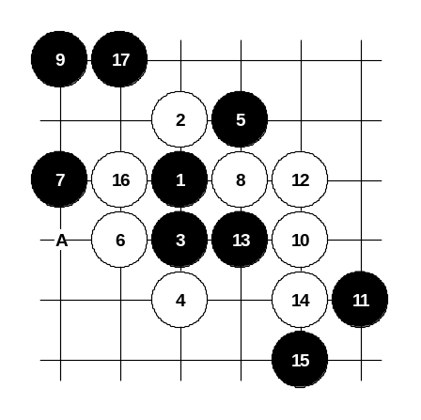
For the advanced and middle class.
This is very well known opening pattern. I think all renju players have played this variant several times. Sometimes their opponents surprise them with the new move. A good player must know other than standard moves, too. In this analysis, I show you the gambling 17th move. According to the theory, the usual 17th move is played to A. After gambling move 17-17 white must try to win. If white fails to win then black is already too strong and so black will win.
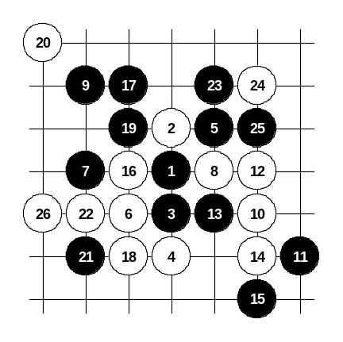
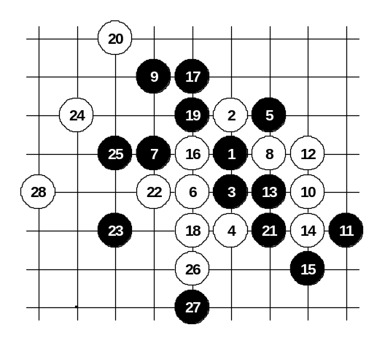
The white win here is quite long, but it is easy to learn because all the attack goes very straight. This is useful to learn for both strong and middle class players. It helps you to understand the essence of this opening pattern and you will understand why 17-A is necessary. Hereby I will present all the diagrams without discussion because these simple diagrams speak for themselves.

